CSA0501-DATABASE MANAGEMENT SYSTEMS
LAB EXPERIMENTS DATE: 14-07-2026

EXPERIMENT 4 -- DML Commands (UPDATE, DELETE)

AIM:
To perform Data Manipulation Language (DML) commands such as UPDATE and DELETE in the Intern_emp_info tables.

PROCEDURE:
- Open MySQL Workbench (or any SQL environment) and connect to the MySQL server.
- Create the required database using the CREATE DATABASE command.
- Select the database using the USE command.
- Create the required tables with appropriate columns and constraints.
- Insert sample records into the tables using the INSERT command.
- Use the UPDATE command to modify the required records in the tables.
- Use the DELETE command to remove the specified records from the tables.
- Execute the SELECT command after each operation to verify the changes made to the tables.
- Ensure that all updates and deletions are successfully reflected in the database.
- Save the SQL script and record the output for verification.

PROGRAM:

1. Update the InternName whoe InternID=301
UPDATE INTERN
SET InternName = 'Nithya Shree Narayani'
WHERE InternID = 301;

SELECT * FROM INTERN;

OUTPUT:
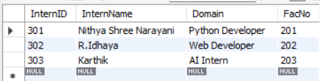

2. Delete the Intern whose FacNo is 203
DELETE FROM INTERN
WHERE FacNo = 203;
SELECT * FROM INTERN;
OUTPUT:
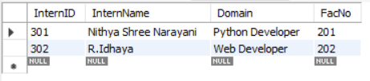

3. Update the FacName where FacNo=202
UPDATE FACULTY
SET FacName = 'Rohan'
WHERE FacNo = 202;

SELECT * FROM FACULTY;
OUTPUT:
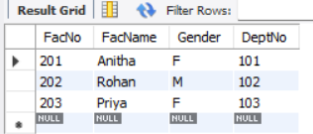

4. Delete the name
DELETE FROM Intern
WHERE InternID = 301;
SELECT * FROM Intern;

OUTPUT:
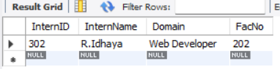

RESULT:

Thus, the Data Manipulation Language (DML) commands such as UPDATE and DELETE were successfully executed and verified in the Intern_emp_info Table.

